LOD-BOG Dev Setup

Prerequisite

1) Eclipse

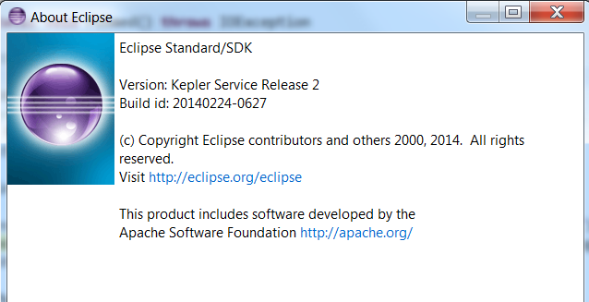

2) Libraries

1. JRE 1.8.0_77
2. Metamap : https://metamap.nlm.nih.gov/
3. Apache Jena 2.12.1 : <https://jena.apache.org/>
4. Stanford Corenlp

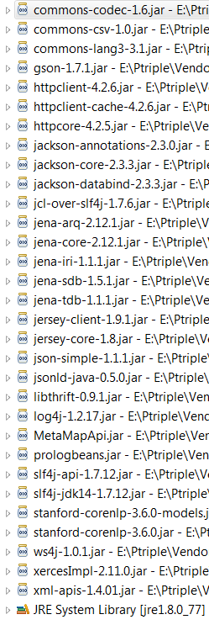

3) The main class is client